TMS Knowledge Base

TMS Server: tms0 (10.1.6.21) – tms0\svcTMS : Spin@62
TMS Server: tms1 (10.1.6.23) – tms1\svcTMS : Spin@62

SQL Server: sql5ids (TMS-TEST.SQL.CORPSERVICES.LOCAL) - sqlTMSTest / Penholder!81

Farel FTP server: remote.farel.com (IPEX MISC DL / toto & JUNJIE / toto)

TMS Services running on server tms0 (win32 process name WDSERVICE.EXE *32):
- Farel TMS Communication INFOFLO (Need to reset parameters after UNIX server is rebooted though manual service mode - FARELTMSIFF)
- Farel TMS GIS (Check PCMiler License Status)
- Farel Optimization
- Farel TMS Rating

Data Exchange Folder re-direct: FARELTMSIFF -> TransferDirectory (T:\ - Live, V:\ - Prep, U:\ - Dev)

TMS Application Path: E:\Farel

Issue: in case the transaction file is not accessible (ex. could not be open with notepad), a server reboot is required. Once the server is reboot, need to restart all 4 services (do a re-initialization of the parameters first before in case the services were left in running state in the database while the server is being reboot. Check the PC miler license status and it might need to be deactivated and re-activated after the reboot also. (Need to coordinate with Renaud and Ivo on how to fix this issue permanently)

FTP info:
erp1ids.erp.corpservices.local
/usr/users/nfs/dev/tms (FTP DEV Data Exchange – IFF_TMS & TMS_IFF)
/usr/users/nfs/live/tms (FTP LIVE Data Exchange – IFF_TMS & TMS_IFF)

Infoflo Project # - SHP096D

Files:
- RFOSFILE
- RFHISTFILE
- RFTBLFILE.LF1
- SHIPTRN
- SHIPTRN.LF1
- SHIPTRN.LF3
- SOPACKFRM
- SOPACKHST

DRPS4055.1 – Main Driver for TMS System, this program feeds TMS from INFOFLO.
(Generate live transactions in PREP account: RUN DEV.CNV.BP CALL_DRP4055).

DRPS4027.1 – Radio Frequency Main Transaction Program

DRPJ4025.10 – Batch program to monitor RF inbound TMS (DRPS4025.10)
I41 -> DRPS4025 (Check TMS_IFF every 15 seconds and stop at 16:50) & DRPS4055
I41 -> DRPS4055 (Setup file location and its extension)

DRP3010 – Radio Freq. Warehouse Maintenance (Turn on / off TMS for specific warehouse)
DRP3015 – Radio Freq. Team Maintenance
DRP4025 – Radio Freq. Order Dispatcher
DRP4028 – Maintain Current Picking Orders
DRP4030 – Radio Freq. Generate B.O.L.
INV3020 – RF Bin Maintenance

NOTE: Every time a TMS reload is required, need to set the corresponding warehouse printer control code (SYS9030) from P to HS to hold the printing for the specific account (DEV.DATA – U:\ drive or PREP.DATA – T:\ drive) !!! Change it back to P when the reloading is done.

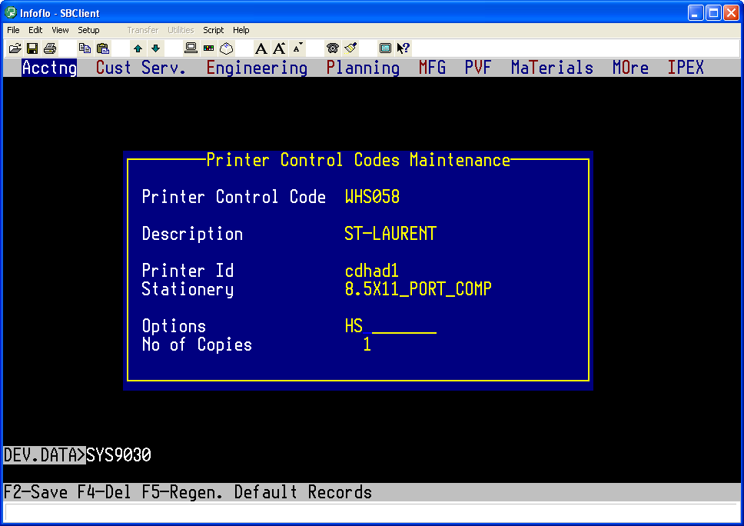

Primary contact (FAREL):
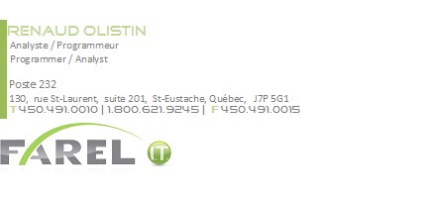
Cell phone: 514-772-6271

Procedure to turn on TMS for a warehouse location:
- Use DRP3010 to double check the TMS flag is not turned on for the warehouse.
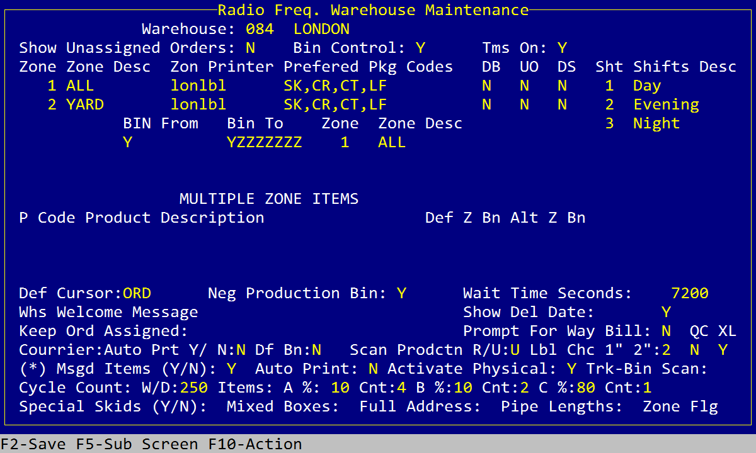
- Use SYS9030 to set the warehouse printer control to HS (e.g. WHS058) to supress the print temporarily.
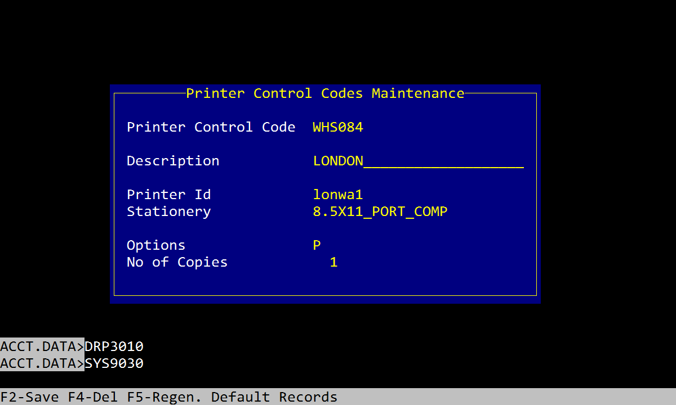
- At TCl, execute command RUN DEV.CNV.BP CALL_DRP4055, enter the warehouse number at prompt, program will reject if the warehouse is already turn on for TMS, otherwise it will turn TMS flag to Y and start generating transaction files in IFF_TMS for the given warehouse.
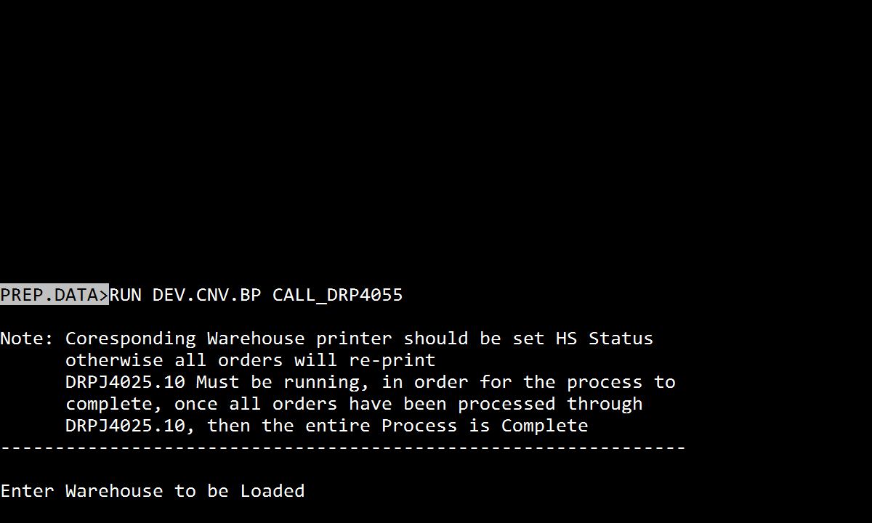
- Once the program is completed properly, all transaction files are generated in IFF_TMS for TMS to pick up, now check the job DRPJ4025.10 (USE TSTJ4025.10 in DEV/PREP
) to validate the freight rates recommendation sending back from TMS for the warehouse.
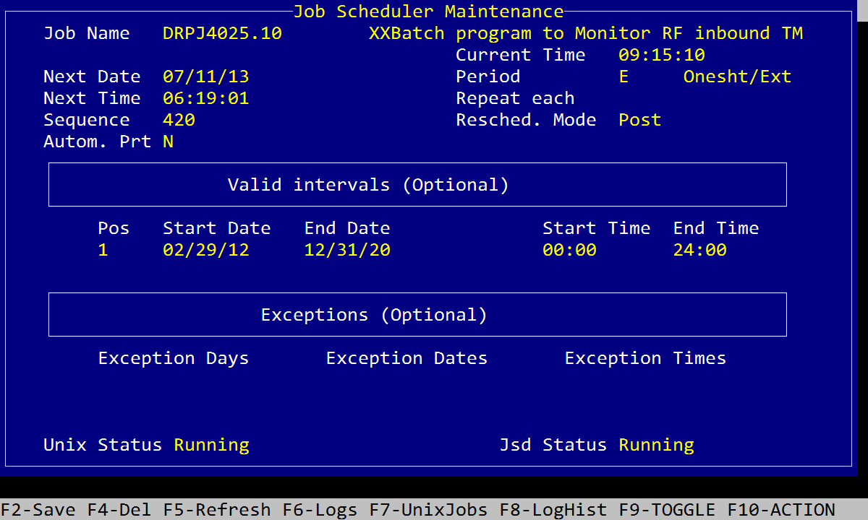
- Done of the procedure.

PCMiler New Address Maintenance by post code through Custom Place Manager function:
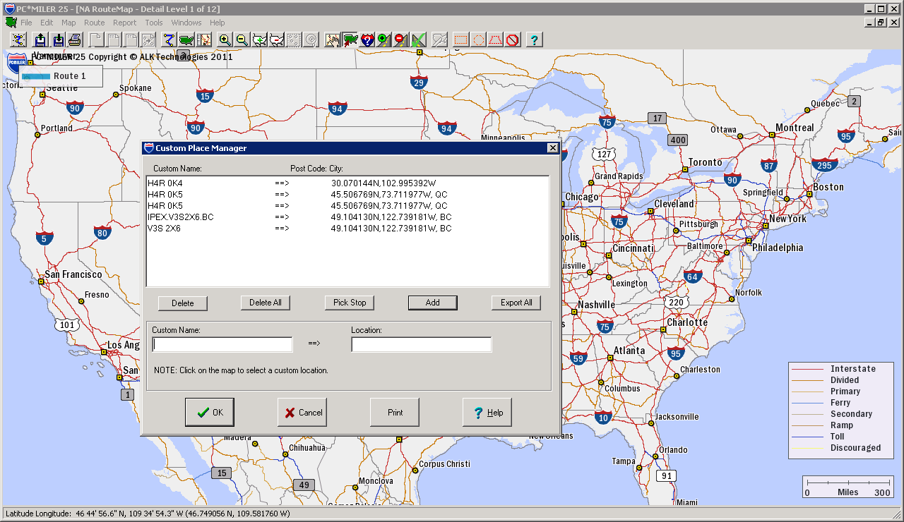

http://geocoder.ca/ (get geocode from post code)

C:\Windows\pcmserve.ini (CustomRoute=true)

PCMiler 25 -> Tools -> Custom Place Manager

Custom Name -> Postal Code (H4R 0K5)
Location -> Latitude, Longitude (45.506769N, 73.711977W)

H4R 0K5 -> 45.506769N, 73.711977W

TMS is using the API function: PCMSAddressToLatLong, with « zip, province code » or « city, province code » as address-parameter.

V3S 2X6 -> 49.104130N, 122.739181W

Procedure for TMS database refresh (DEV / PREP):

- Use SYS9030 to set the warehouse printer control to HS (e.g. WHS058) to supress the print temporarily.
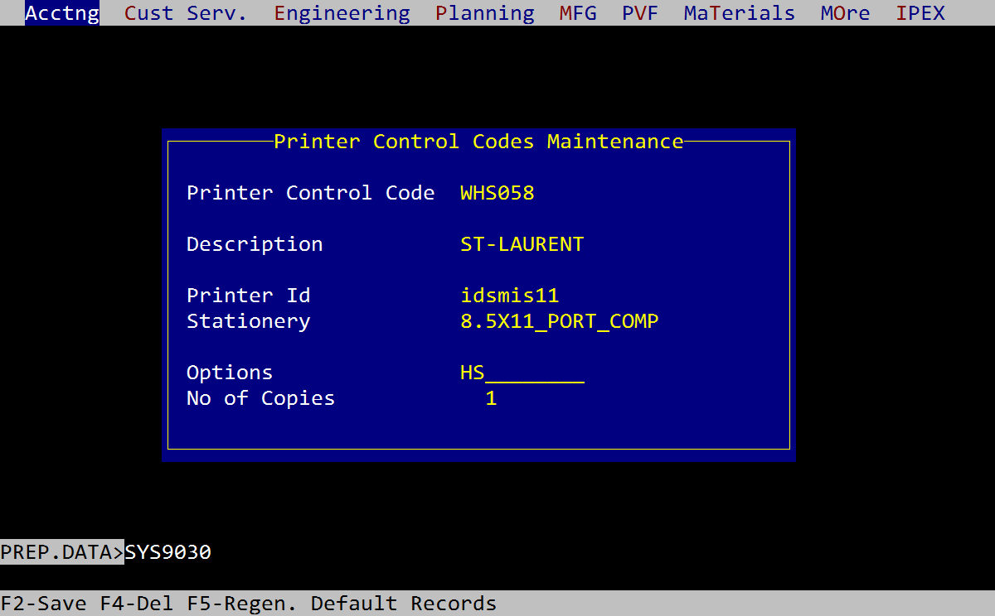
- Use SYS9030 to set the BOL printer control to HS (e.g. BOL058) to supress the print temporarily.
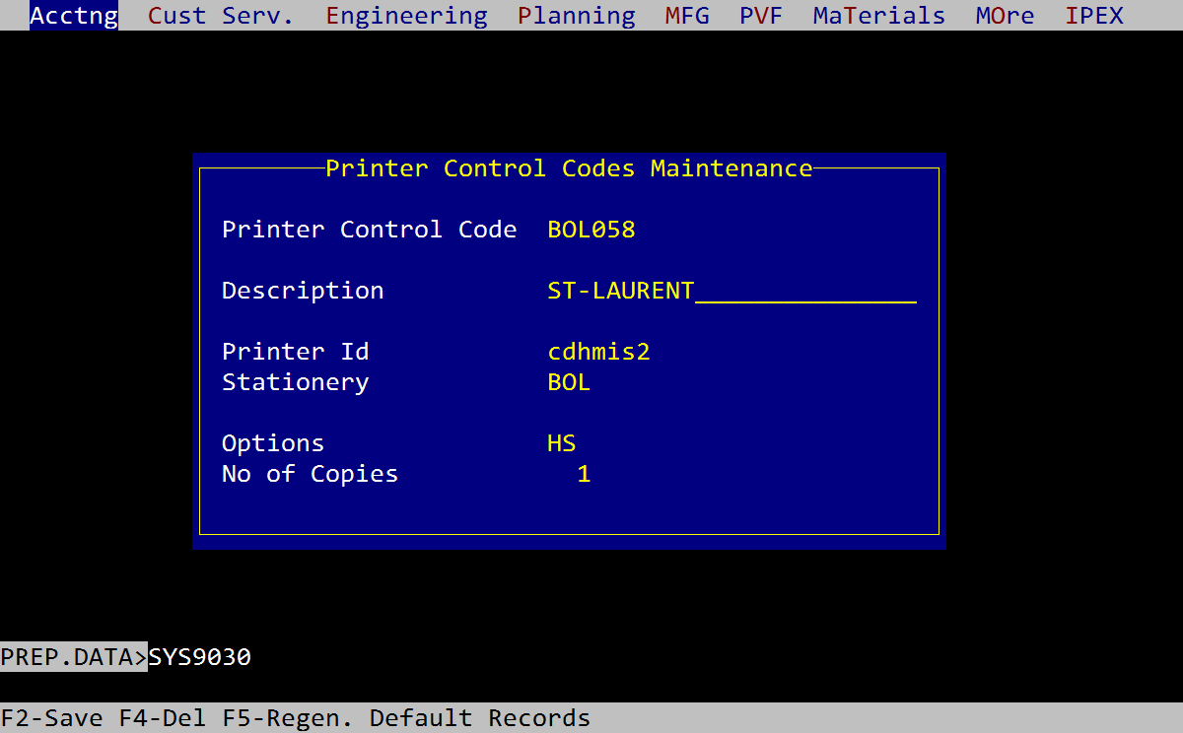
- Make sure the job TSTJ4025.10 (DRPJ4025.10 in LIVE) is up running.
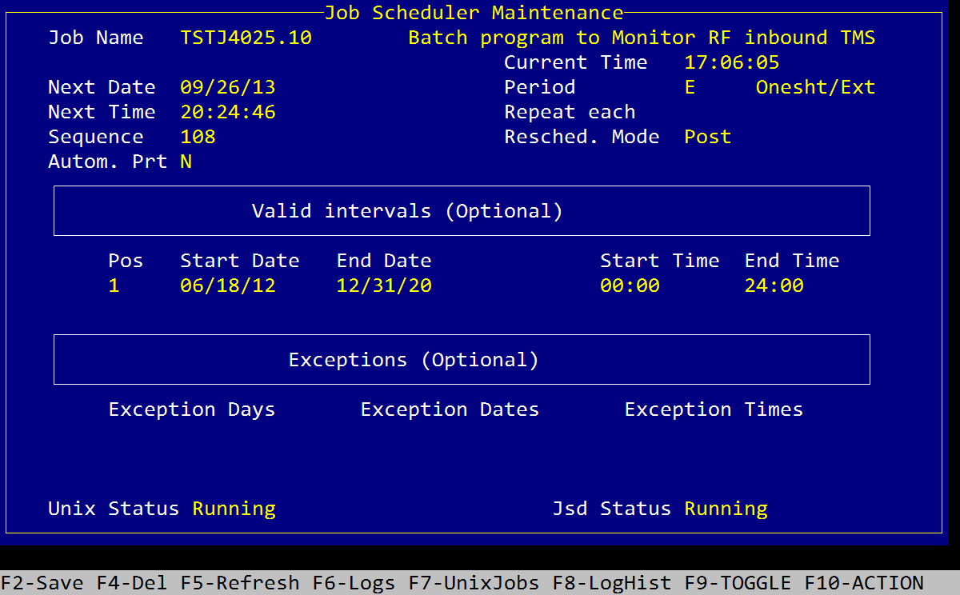
- At TCl, execute command RUN DEV.CNV.BP CALL_DRP4055, enter the warehouse number at prompt, program will reject if the warehouse is already turn on for TMS, otherwise it will turn TMS flag to Y and start generating transaction files in IFF_TMS for the given warehouse.

